**C64 PSU Combi Rev. 1**

**Testing**

# Device Under Test/Used Equipment

The test was carried out with a PCB assembly Rev. 1. The DC-power supply was a Mean Well RD-50A. The 5V output of said DC-power supply was set to 5.2V. The DIN power cables were made from 4x0.5mm²(AWG21) cables and are 130cm long.

The voltage measurements were done with a Fluke 89IV, the current measurements with a Voltcraft VC160 multimeter.

The PSU was loaded with load resistors

|  |  |
| --- | --- |
| **Load Resistor nominal** | **Measure resistance (@22°C)** |
| 4.7Ω/10W | 4.9Ω |
| 10Ω/25W | 10.1Ω |
| 18Ω/25W | 18.1Ω |

The value of the load resistors varies with temperature.

# Output Voltages

## Measurements (Vmains = 230VAC/50Hz)

|  |  |  |  |  |
| --- | --- | --- | --- | --- |
| **Voltage nominal** | **Load Resistor** | **Voltage (no load)** | **Voltage (load)** | **Current (loaded)** |
| +5V | 4.7Ω | 5.16V | 4.98V | 1.01A |
| +12V | 10Ω | 12.0V | 11.55V | 1.14A |
| 9VAC | 10Ω | 12.6VAC | 10.05VAC | 0.99A(AC) |

The 9VAC output is not regulated, like in the original power supply, it is the output voltage of a transformer. The rated output voltage only applies when the nominal load is connected. This value is not critical for the operation, since the internal voltages of the C64, which are generated from the 9VAC are regulated. The higher than rated voltage without load and the high voltage drop with a 1A load are a normal behavior of transformers.

The voltage drop of the +12V is not critical for the operation, too. The sources of the voltage drop will be tracked, though.

The little voltage drop of the +5V (with load) is not critical, since the voltage of the DC power supply can be set higher if required. 5.2V seems to be an ideal setting. However, the cause of the voltage drop needs to be investigated.

## Measurements (Vmains = 115VAC/50Hz)

|  |  |  |  |
| --- | --- | --- | --- |
| **Voltage nominal** | **Load Resistor** | **Voltage (no load)** | **Voltage (load)** |
| +5V | 4.7Ω | 5.21V | 4.98V |
| +12V | 10Ω | 12.01V | 11.50V |
| 9VAC | 10Ω | 12.4VAC | 9.80VAC |

The measurements with 115V Mains were performed with a 230V to 115V transformer (Bronson++/TI-300). The mains selector switch was set to 115V.

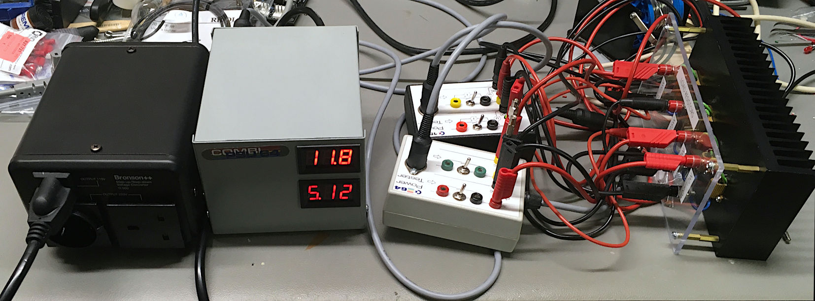

Figure 1: test setup with 115V mains transformer

## Tracking the +5VDC

The voltage with load, measured at J3 is 5.200V. The voltage measured at the output connector for the C64 (J4) is 5.146V. The voltage measured at the (C64) output jack (loaded) of the PSU was 5.130V. The voltage drop between the DC-PSU and the output jack totals 70mV, which is an acceptable value. At the DIN connector of the cable (at the PSU side, a value of 5.125 V was measured. 5.016V were measured at the DIN connector at the load side. 4.984V were measured inside at the power test box.

|  |  |
| --- | --- |
| **Item** | **Voltage drop** |
| PCB | 54mV |
| Cable to C64 DIN connector | 16mV |
| DIN jack – DIN plug (PSU) | 5mV |
| Cable | 109mV |
| DIN plug – DIN jack (Test box) | 32mV |

Most of the voltage drop occurred via the cable. The resistance of a 0.5mm² coper cables is approximately 43.4mΩ/meter. This totals in about 113mΩ for the 2x1.3m (+5V lead and ground lead), which proves the measurement (0.113Ω x 1.01A = 114mV).

## Tracking the +12V

|  |  |  |
| --- | --- | --- |
| **Measurement** | **Reading** | **Drop** |
| @J3 (no load) | 11.999V |  |
| @ DC-PSU (with load 10Ω) | 11.789V | Regulation: 210mV |
| @J3 (with load 10Ω) | 11.789V |  |
| @J6 (with load) | 11.719V | 70mV |
| @output jack (with load) | 11.702V | 17mV |
| @ DIN plug/output cable (PSU side) | 11.697V | 5mV |
| @ DIN plug/output cable (Tester side) | 11.538V | 159mV |

The load regulation is contributing most of the voltage drop when a load is applied. This is a property of the DC PSU. But again, the cable is clearly contributing a lot to the voltage drop, more than the rest of the system. The load is higher than a regular disk drive, though.

# Thermal testing

Two K-type thermo couples have been installed in the device under test. T1 was positioned above the DC power supply, T2 above the transformer (Figure 1). The case was closed, the cut out for one panel meter that was removed to feed the thermo couple through the front of the case.

The +5V was loaded with 4.7Ω in parallel with a 10Ω load resistance, which results in a 3.2Ω load. The +12V was loaded with 10Ω and the 9VAC with 18Ω.

The test was conducted over 5 hours. The temperatures were monitored (Figure 2).

|  |  |  |
| --- | --- | --- |
| **Time** | **Sensor T1** | **Sensor T2** |
| 0:00h | 21.5°C | 21.5°C |
| 1:05h | 37.3°C | 39.3°C |
| 1:41h | 39.2°C | 42.9°C |
| 2:41h | 40.1°C | 45.0°C |
| 3:10h | 39.7°C | 45.0°C |
| 5:18h | 39.9°C | 44.3°C |

The temperatures stabilized over time. According to the datasheet the maximum ambient temperature for the Mean Well RD-50 is 70°C and for the transformer, it is 70°C as well. Those limits are by far not reached. Thus, the thermal properties of this power supply are not critical.

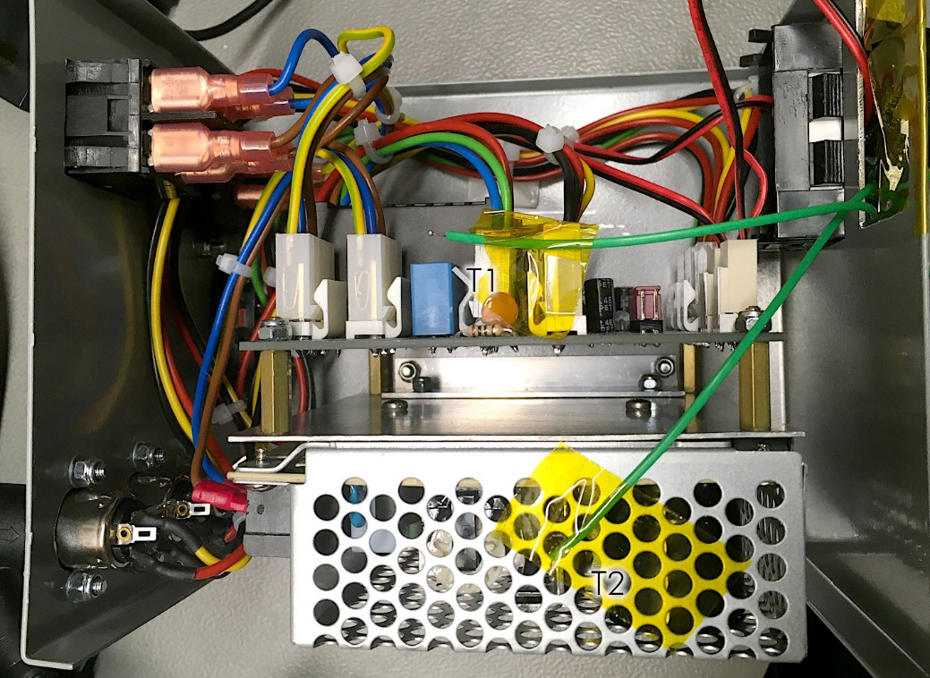

Figure 2: Position of the thermo couples

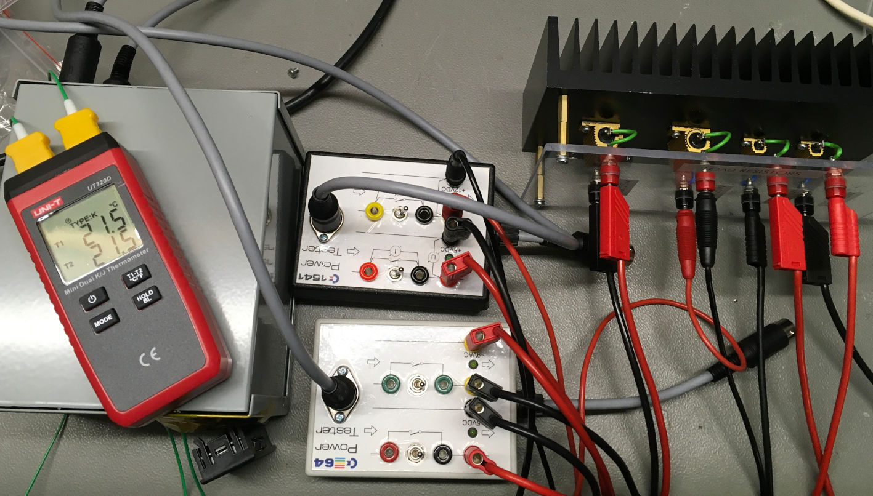

Figure 3: Thermal test setup

The thermal image Figure 3) shows, that the transformer is the warmest component in the design.

The temperatures in Figure 3 are not accurate, since the emissivity was set to “matt surfaces”. The maximum temperature in at the left is high due to the glossy kapton tape. So, the picture has to be interpreted as “qualitative”.

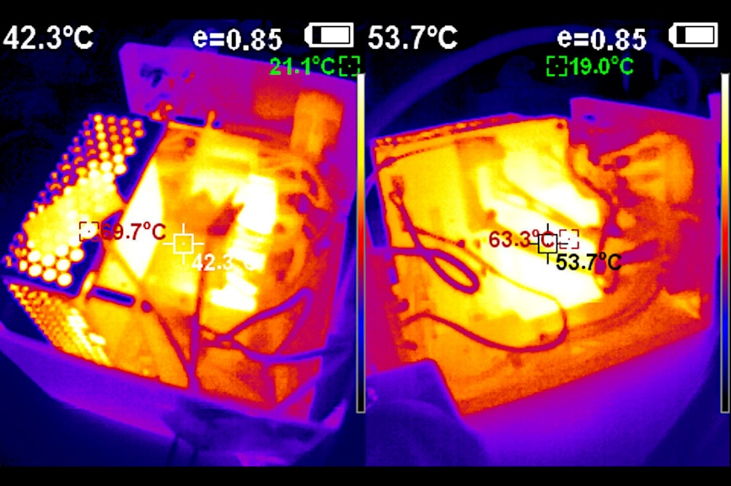

Figure 4: Thermal image of the PSU combi at the end of the test

# Noise measurement

The noise measurements were carried out with a load:

* +5VDC: 3.2Ω
* +12VDC: 10Ω
* 9VAC: 18Ω

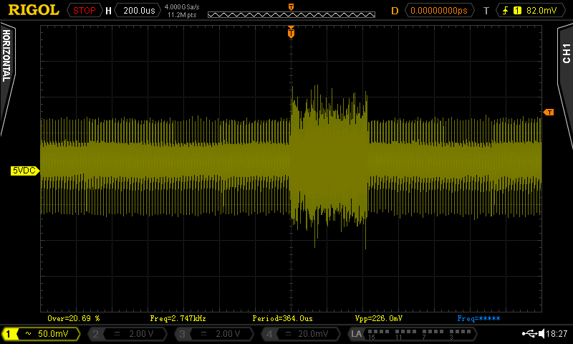

Figure : 5VDC (1div=200µs): Vpp =226mV

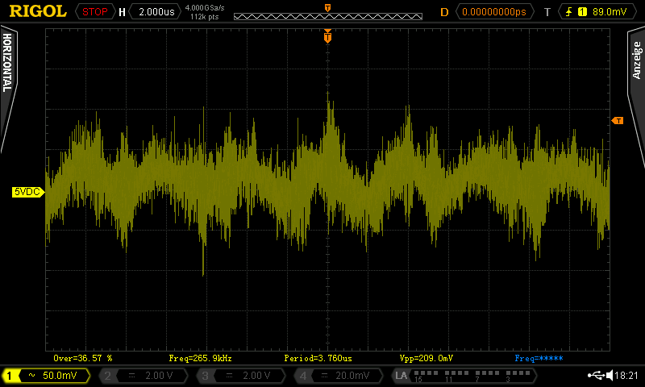

Figure : 5VDC (1div = 2µs): Vpp = 209mV

The noise on +5VDC is a property of the DC PSU (Mean Well RD-50A). Figure 5 shows, that this noise is a periodic phenomenon. Figure 6 shows this noise burst in detail.

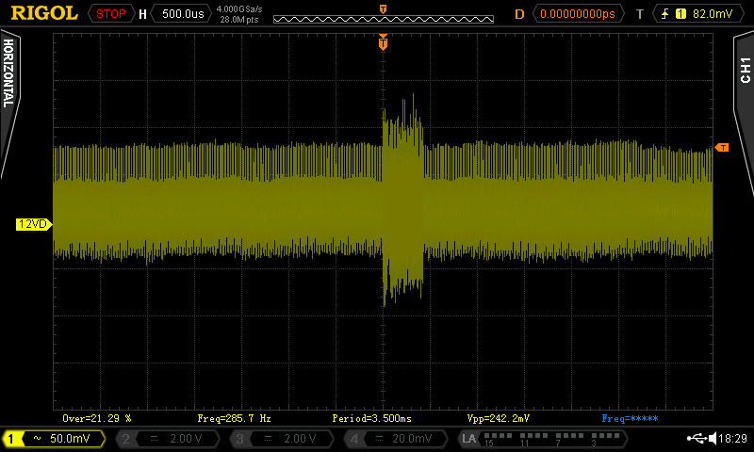

Figure : +12VDC (1div = 500µs): Vpp = 242mV

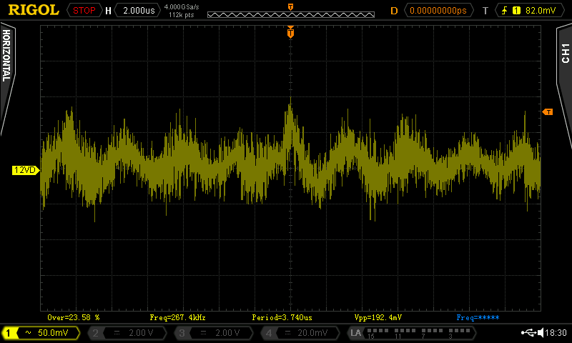

Figure : +12VDC (1div = 2µs): Vpp = 192mV

The noise on +12VDC is a property of the DC PSU. Figure 7 shows, that this noise is a periodic phenomenon. Figure 8 shows this noise burst in detail.

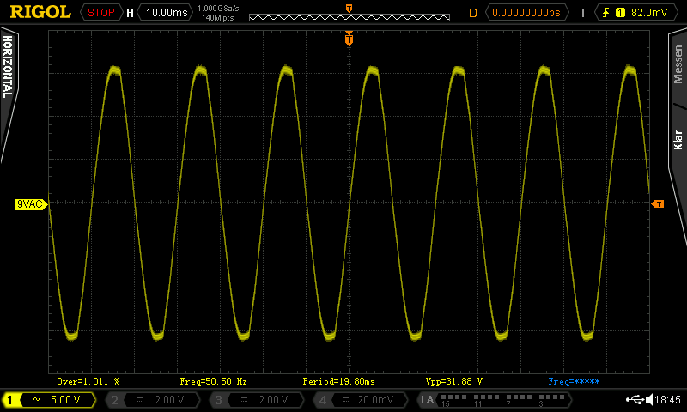

Figure : 9VAC

Figure 9 shows the 9VAC. 31.88Vpp means an *amplitude* of 15.94V. This is not the RMS value, which is measured with the multimeter. The sinewave looks properly, it is not heavily distorted.

# Real Life **Test**

The power supply was tested with the C64 ASSY

* 250407
* 250425
* 250466
* 250469

And two 1541-II. All setups worked without a problem.

# Conclusion

**The C64 PSU combi Rev. 1 is fully functional.**